HOME SECURITY WITH MOTION DETECTION

MINI PROJECT REPORT
for
21CSS201T - COMPUTER ORGANIZATION AND ARCHITECTURE

Submitted by

VOONNA VENKATA KAMAL SAI [Reg no : RA2311028010055]
G CHETHAN AKASH [Reg no: RA2311028010059]
T SRIKANTH [Reg no : RA2311028010072]
V AJAY KUMAR REDDY [Reg no : RA2311028010077]

Under the Guidance of
Dr .R.KAYALVIZHI
(Assistant Professor, Department of Networking and Communications)

In partial fulfillment of the requirements for the degree of

BACHELOR OF TECHNOLOGY
in
COMPUTER SCIENCE ENGINEERING
with specialization in CLOUD COMPUTING



DEPARTMENT OF NETWORKING AND COMMUNICATIONS
SRM INSTITUTE OF SCIENCE AND TECHNOLOGY
KATTANKULATHUR- 603 203
NOVEMBER 2024


SRM INSTITUTE OF SCIENCE AND TECHNOLOGY
KATTANKULATHUR – 603 203

BONAFIDE CERTIFICATE

Certified that Computer Architecture and organization Mini Project report titled “HOME SECURITY WITH MOTION DETECTION” is the bonafide work of “ARJUN MANNAM” [RA2311028010040], “VOONNA VENKATA KAMAL SAI” [RA2311028010055], “G CHETHAN AKASH” [RA2311028010059], who carried out the project work under my supervision. Certified further, that to the best of my knowledge the work reported herein does not form any other work

Dr.T. Preethiya  Assistant Professor  Dept. of Networking and  Communications | Dr. Lakshmi M  Professor & Head Professor  Dept. of Networking and Communications



SRM Institute of Science and Technology
College of Engineering and Technology
SCHOOL OF COMPUTING

MINI PROJECT REPORT

ODD Semester: 2024-2025

Sub code & Sub Name : 21CSS201T & Computer Organization and Architecture

Year & Semester : II & III

Project Title : HOME SECUITY WITH MOTION DETECTION

Team Members :
1.ARJUN MANNAM (RA2311028010040)
2.VENKATA KAMAL SAI VOONNA(RA2311028010055)
3.G CHETHAN AKASH (RA2311028010059)

Particulars | Max. Marks | Marks Obtained
Review 1 and 2 | 05
Demo verification &viva | 03
Project Report | 02
Total | 10

Date :

Staff Name : Dr.T. Preethiya

Signature :

TABLE OF CONTENTS

SR.NO | TITLE | Page No
1 | - OBJECTIVE  - ABSTRACT | 5
2 | 2 INTRODUCTION | 6
3 | 3.1 HARDWARE REQUIREMENT  3.2 SOFTWARE REQUIREMENT  3.3 WIRING CONNECTION | 6-7
4 | 4.1 CONCEPT/WORKING PRINCIPLE  4.2 CIRCUIT DIAGRAM | 8-10
5 | 5.1APPROACH/METHODOLOGY/ PROGRAM  5.2 OUTPUT  5.3 IMAGES OF THE PROJECT | 10-14
6 | 6.1 CONCLUSION  6.2 REFERENCES  6.3 MAKING VIDEO LINK | 15-16

HOME SECURITY WITH MOTION DETECTION

1.1 OBJECTIVE:

The primary objective of a home security system with motion detection is to enhance the safety and security of a residential property by continuously monitoring the premises for any unauthorized movement. This system aims to provide early warning of potential intrusions, deter crime, and alert homeowners or security personnel of any unusual activity, allowing for a quick response. Specific goals include:
Intrusion Detection
Real-Time Alerts
Enhanced Surveillance
Cost Efficiency
Energy Efficiency

1.2 ABSTRACT:
Home security systems with motion detection play a crucial role in enhancing residential safety by providing real-time monitoring and immediate alerts upon detecting unauthorized movement. These systems integrate sensors and cameras to detect and record any unexpected activity within the property, deterring potential intruders and allowing homeowners or security personnel to respond promptly. Motion-detection technology minimizes the need for constant human surveillance, improving efficiency by activating only when movement is detected. This technology not only provides peace of mind but also contributes to a safer, more secure living environment through efficient and cost-effective surveillance. The system’s ability to deliver real-time notifications to the homeowner’s device enhances responsiveness and adds an extra layer of security.

2 INTRODUCTION:

In an increasingly interconnected world, home security is a top priority for many households. Motion detection technology has revolutionized the way we protect our homes, making security systems more responsive, reliable, and intelligent. Motion detectors use sensors to detect any movement within a designated area, immediately triggering alarms or alerts when unexpected activity occurs. This technology offers numerous benefits, including real-time monitoring, deterrence of potential intruders, and quick response capabilities. By integrating motion detection with modern home security systems, homeowners can enjoy greater peace of mind, knowing that their homes are safeguarded with the latest advancements in security technology.

3.1 HARDWARE REQUIREMENTS:

· 1x Arduino Uno SMD
· 1x PIR Sensor
· 1x 20x4 I2C LCD Display
· 1x Buzzer
· 1xLED
· 10xMale-Female Jumpers

3.2 SOFTWARE REQUIREMENTS:
-> Microcontroller Software:
Code to control sensors and motors for home security
-> The Arduino IDE is a user-friendly platform designed for programming Arduino boards, making it an excellent choice for the smart dustbin project. It features a straightforward code editor with syntax highlighting, which helps in writing clear and organized code. The built-in library manager allows for easy integration of various sensors and components, while the serial monitor provides real-time data for debugging. This simplifies the development process, enabling quick iterations and adjustments as needed.
-> Using simple Cpp code within the Arduino IDE allows for efficient programming of the dustbin's functionalities. The core structure consists of the setup() function for initializing sensors and the loop() function for continuously processing data. Control structures, like conditionals, can be used to determine whether the waste is wet or dry based on sensor readings. This modular approach ensures that the code remains manageable and easy to debug, facilitating the creation of a reliable and effective smart dustbin system
3.3 WIRING CONNECTION :

- **PIR Sensor**: Power to 5V and GND, Output to Pin 2.
- **LED**: Positive (long leg) to Pin 13 (with 220Ω resistor), Negative (short
leg) to GND.
- **Buzzer**: Positive to Pin 12, Negative to GND.
- **I2C LCD**: SDA to A4, SCL to A5, VCC to 5V, and GND to GND.

4.1 CONCEPTS/WORKING PRINCIPLE

1. Motion Detection Sensors
Passive Infrared (PIR) Sensors: The most commonly used sensors in home security systems detect infrared radiation emitted by humans and animals. When someone moves within the sensor's range, it detects the change in infrared levels, triggering an alert.
Microwave Sensors: These sensors emit microwave pulses and measure the reflection off a moving object. They can cover larger areas but may be prone to interference.
Ultrasonic Sensors: These work by emitting ultrasonic waves and detecting changes in their reflection. They are highly sensitive but can sometimes pick up false alarms due to animals or objects.

2. Control Unit and Processing
The control unit is the "brain" of the system. It processes signals from the sensors and makes decisions on whether the movement is significant enough to trigger an alert.
Some systems also use AI-based processing to distinguish between human movement and non-threatening objects like pets or shadows, reducing false alarms.

3. LCD Display
The LCD screen displays real-time information from the motion detectors, such as whether movement is detected and where it’s located.
Advanced systems can show a live video feed if connected to a camera, allowing the user to see exactly what triggered the motion detection.
Some screens also display system status, like armed/disarmed status, battery levels, and network connection status.
4. Alarm
When motion is detected, the system may trigger an alarm sound

5. Power Supply and Backup
These systems usually run on the main power supply but also have a battery backup to ensure functionality during a power outage.
Low-power components and efficient algorithms are often used to minimize energy consumption.

Working Principle
When a person or object moves within the detection range, the sensors sense the movement.
The signal is sent to the control unit, which processes the information.
Based on the preset sensitivity levels, the control unit decides if an alarm needs to be triggered.
If triggered, the LCD screen displays the alert and may show additional details or live footage if connected to a camera.
The alarm may activate, and notifications can be sent to a registered device.
This type of system is commonly used in smart homes for security, as it provides real-time updates and alerts, making it easy to monitor and respond to potential security breaches.

4.2 CIRCUIT DIAGRAM :

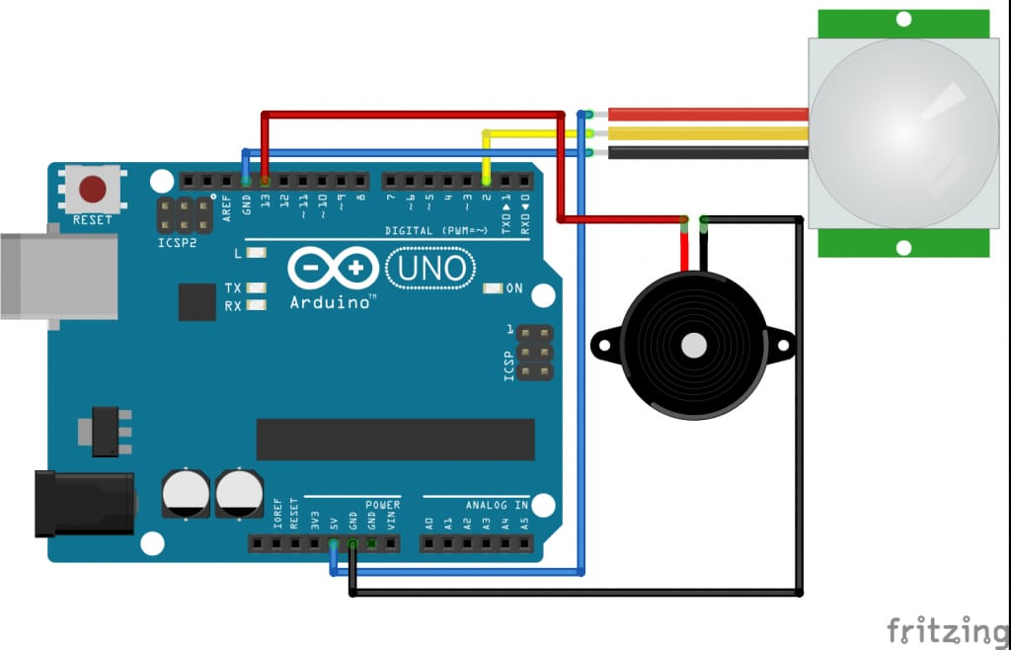

5.1 APPROACH/METHODOLOGY/PROGRAMS:

#include <Wire.h>
#include <LiquidCrystal_I2C.h>
// Set the LCD I2C address (you might need to adjust this based on your display)
LiquidCrystal_I2C lcd(0x27, 20, 4);
int pirPin = 2; // Pin connected to PIR sensor
int ledPin = 13; // Pin connected to LED
int buzzerPin = 12; // Pin connected to Buzzer
int pirState = LOW; // Variable to track motion state
int pirVal = 0; // Reading from PIR sensor
void setup() {
pinMode(pirPin, INPUT); // Set PIR sensor as input
pinMode(ledPin, OUTPUT); // Set LED as output
pinMode(buzzerPin, OUTPUT); // Set buzzer as output
Serial.begin(9600); // Start serial monitor
lcd.init(); // Initialize the LCD
lcd.backlight(); // Turn on the backlight
lcd.setCursor(0, 0); // Set cursor to the first line
lcd.print("Home Security"); // Initial message on the display
delay(2000); // Wait for 2 seconds
lcd.clear(); // Clear the LCD screen
}
void loop()
{
pirVal = digitalRead(pirPin); // Read PIR sensor value
if (pirVal == HIGH) { // If motion is detected
digitalWrite(ledPin, HIGH); // Turn LED on
digitalWrite(buzzerPin, HIGH); // Sound the buzzer
if (pirState == LOW) {
lcd.clear(); // Clear the LCD screen
lcd.setCursor(0, 0); // Set cursor to the first line
lcd.print("Motion Detected"); // Display motion detection message
Serial.println("Motion detected!");
pirState = HIGH; // Update motion state
}
}
else { // If no motion is detected
digitalWrite(ledPin, LOW); // Turn LED off
digitalWrite(buzzerPin, LOW); // Stop the buzzer
if (pirState == HIGH) {
lcd.clear(); // Clear the LCD screen
lcd.setCursor(0, 0); // Set cursor to the first line
lcd.print("No Motion"); // Display no motion message
Serial.println("Motion ended!");
pirState = LOW; // Update motion state
}
}
lcd.setCursor(0, 2); // Set cursor to the third line
lcd.print("PIR Status: "); // Display PIR status
if (pirVal == HIGH) {
lcd.print("HIGH "); // Display HIGH if motion is detected
}
else {
lcd.print("LOW "); // Display LOW if no motion is detected
}
}


5.2 OUTPUT:

5.3 IMAGES OF THE PROJECT
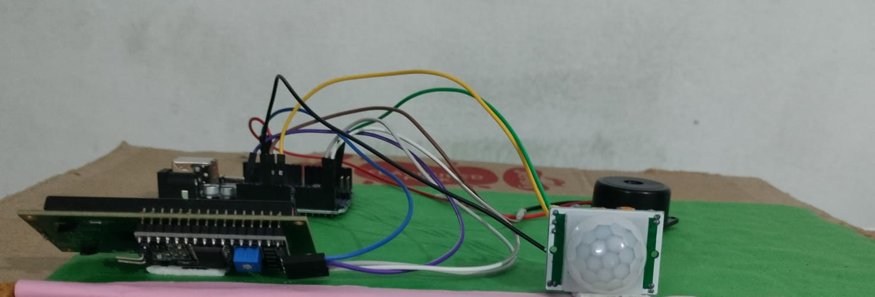

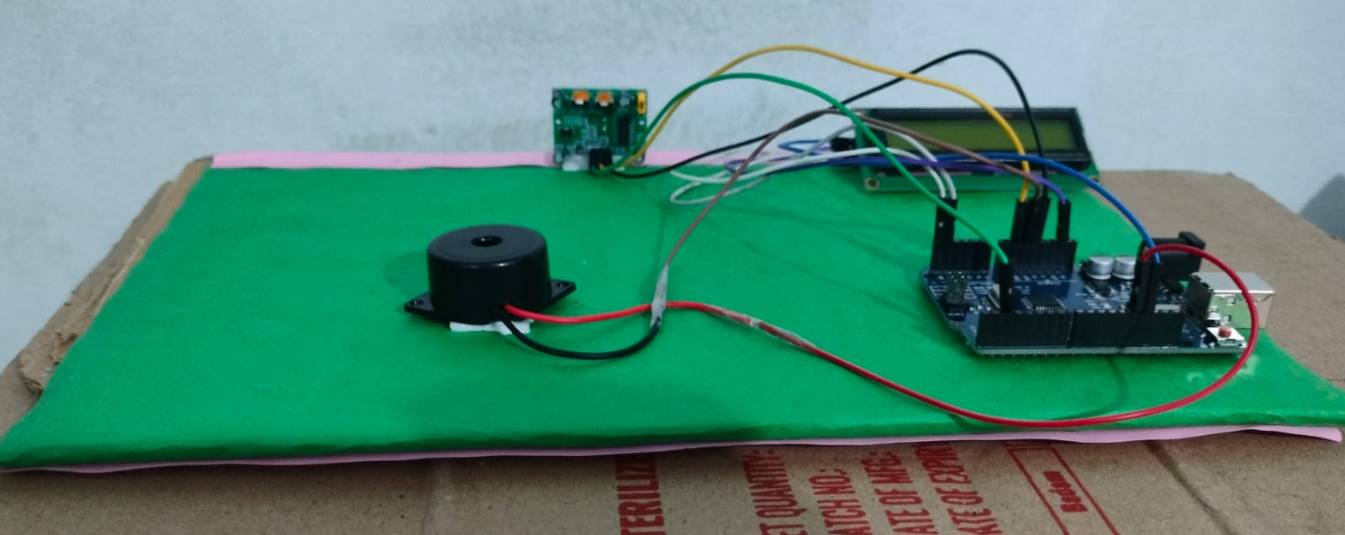
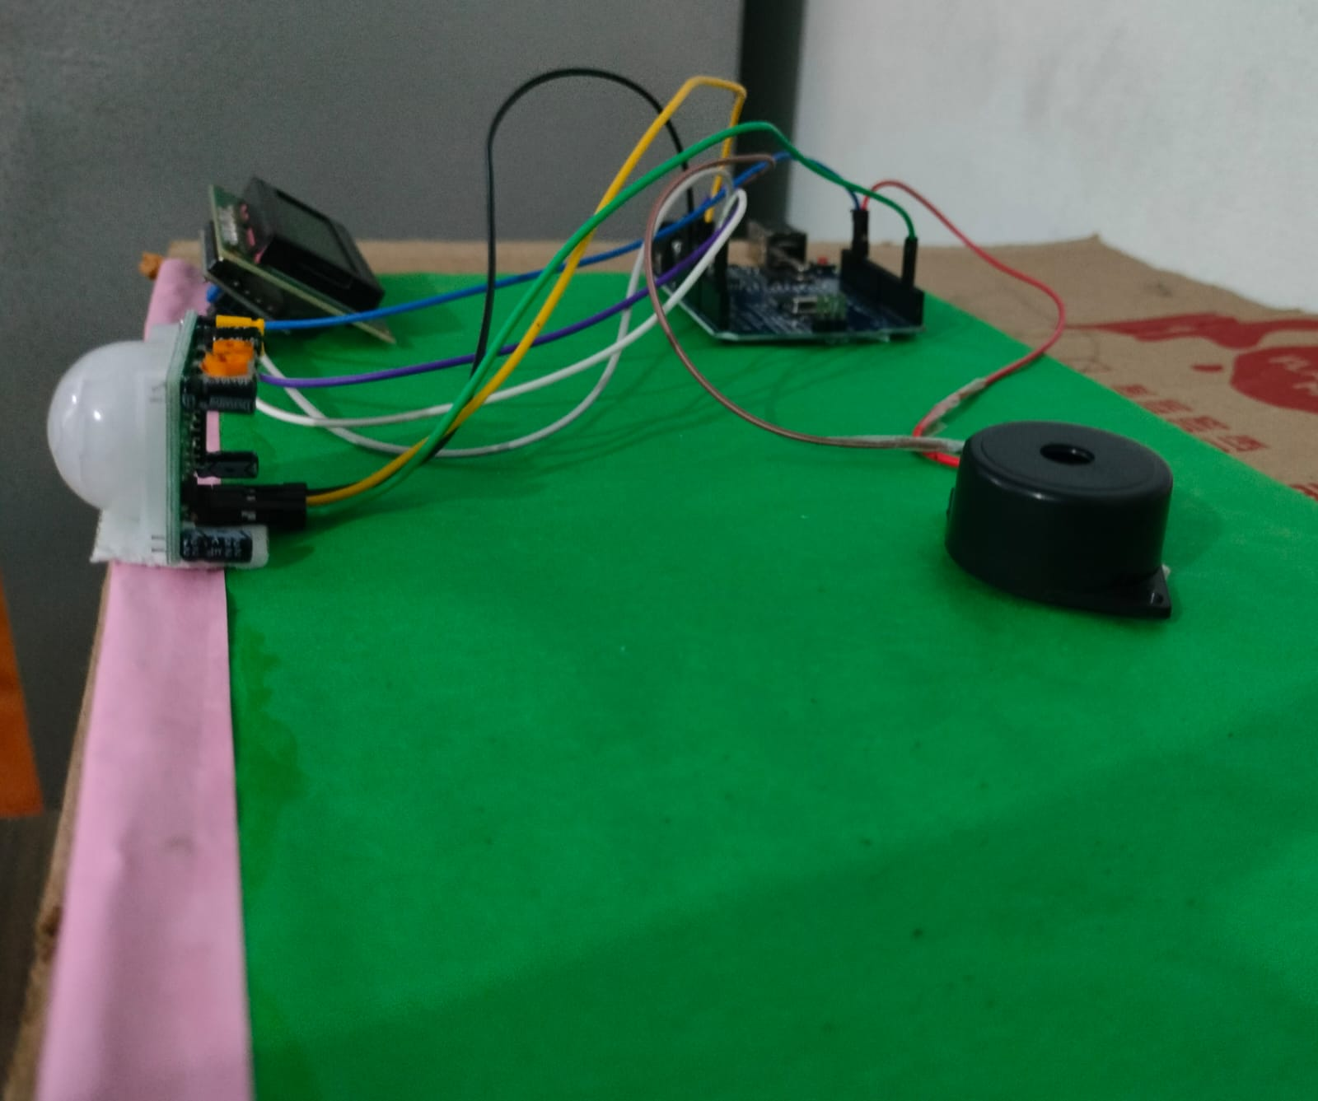

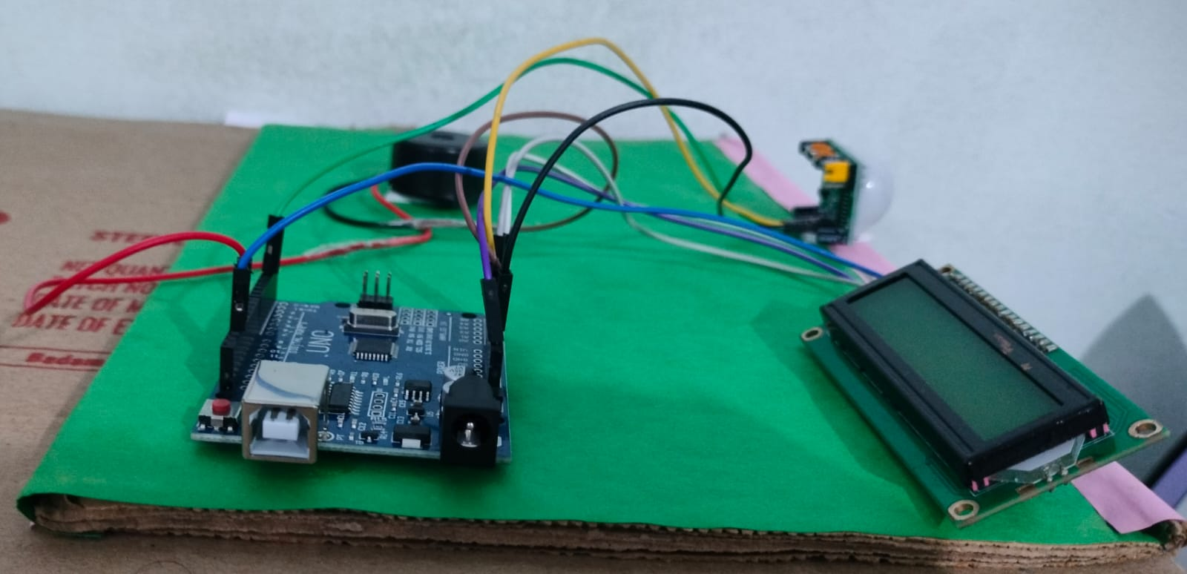

6.1 CONCLUSIONS:

In conclusion, a home security system with motion detection is a highly effective and accessible solution for safeguarding homes. By utilizing motion sensors, control units, and display systems, these setups provide real-time monitoring and alerts, offering peace of mind to homeowners. Advanced motion detection reduces false alarms and enhances accuracy, while LCD screens or connected devices allow users to monitor their home environment easily.

With continuous innovations, such systems are becoming more efficient, reliable, and user-friendly, making them an invaluable asset for modern home security. In a world where security threats are constantly evolving, investing in a motion-detection security system represents more than just a protective measure; it is a step towards embracing an intelligent, connected lifestyle.

These systems are becoming essential tools in modern home management, ensuring that safety remains a priority without compromising on convenience. Continuous innovation in this field is paving the way for more efficient, cost-effective, and personalized home security solutions, making them an invaluable asset for today’s homeowners who value both security and control.

6 .2 REFERENCES:
1."A Smart IoT Security System for Smart-Home Using Motion Detection and Facial Recognition"

Authors: B. Saeed, M. M. Ahmed, M. F. A. Al-Dabbagh
Year: 2020
Summary: This paper focuses on a smart home security system using IoT technology, incorporating PIR motion sensors and facial recognition for better security.

2."IoT Smart Door System with Motion Sensing and Facial Recognition"

Authors: S. Jain, A. Mishra, K. M. Singh
Year: 2021
Summary: Discusses a smart door system using IoT for enhanced access control with facial recognition and motion detection, intended for secure home entry.

6.3 MAKING VIDEO LINK :

https://drive.google.com/drive/folders/1--Hjy8yRrsmxaFmPhEKOIj84KaSInvX0

